Descriptive Analysis of German Cars Dataset

Arun Radhakrishnan (002933307)

ALY6010: Final Project — Final Project, Northeastern University Instructor – Dr. Hootan Kamran Habibkhani
June 30th, 2023

Introduction

The "Germany Cars" dataset is a compilation of auto data that offers details on the numerous car models sold in Germany. The dataset comes from Kaggle and includes important information on the cars, like their make, model, year, price, horsepower, mileage, fuel type, and many other characteristics.

The dataset is a useful tool for conducting data analysis and learning more about the German automobile market. It can be used to investigate patterns, trends, and connections between various automotive attributes. This dataset can be used by analysts, researchers, and fans to do a variety of analyses, such as market research, price prediction models, feature importance analysis, and more.

Variables of the Dataset:

Make: The brand or manufacturer of the car.

Model: The specific model’s name or variant of the car.

Year: The manufacturing year of the car.

Price: The price of the car in Euros.

Horsepower: The horsepower rating of the car.

Mileage: The mileage of the car in kilometers.

Fuel Type: The type of fuel used by the car (e.g., Petrol, Diesel, Electric).

Gear: The transmission type of the car (e.g., Manual, Automatic).

Mileage: The number of kilometers the car was driven when the data was collected.

Source: https://www.kaggle.com/code/jcraggy/germany-cars-r/input

The dataset provides an in-depth look at the attributes of cars and allows for exploration and analysis. Researchers can learn more about what affects automobile costs by analyzing this information, as well as learn about popular car models, fuel preferences, and the effect of different qualities on performance. Before beginning any analysis or modelling, it is essential to perform data cleaning, preprocessing, and exploratory data analysis, as with any dataset. This guarantees the dependability and accuracy of the dataset's results.

Data Cleaning

Initial process was to identify the number of null records present in the dataset. And below (Figure 1.1) is the tabular format of null records per variable.

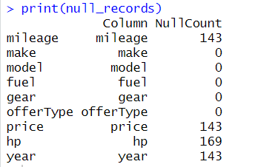

Figure 1.1

The null records are further analyzed and is found that these records do not carry any specific information about the dataset and hence are omitted.

Further variable Fuel, Gear, Mileage is analyzed, and data is cleaned accordingly. (Refer Milestone 1 & 2)

Data Analysis

The structure of the dataset is displayed in Figure 2.1. The filtered dataset contains 45,936 records containing 9 variables. Followed by Figure 2.2 provides the summary of key variables Price, Year and Mileage. Year variable follows a normal distribution and variables Price and Mileage positively skewed.

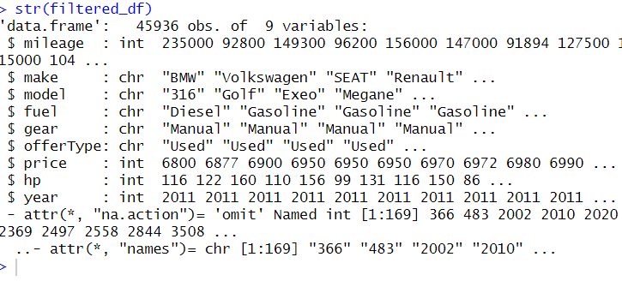

Figure 2.1

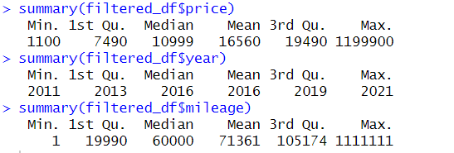

Figure 2.2

Box plot comparing price of the car vs year in Figure 2.3 shows a standard incline in the price of the car throughout the years.

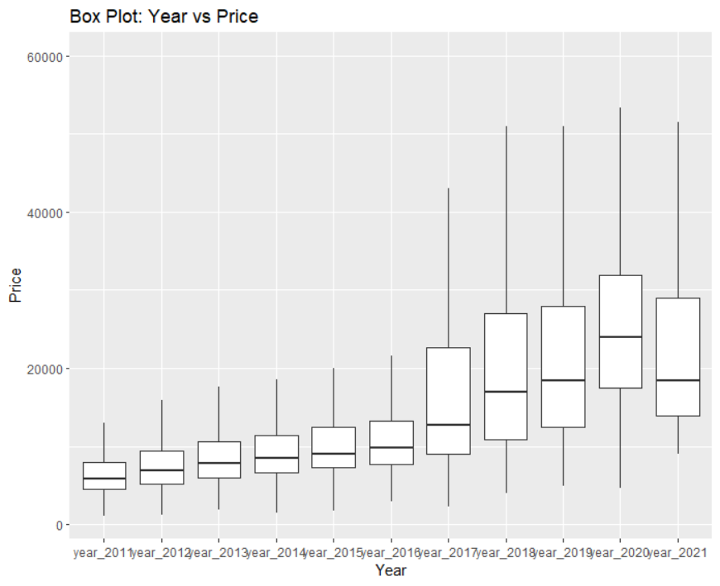

Figure 2.3

Correlation plot: Both Price vs hp and Price vs year have a positive correlation, indicating that higher horsepower may be associated with higher prices and newer cars tend to have higher prices respectively. On the other hand, there is a negative correlation between price and mileage, suggesting that as mileage increases, the price tends to decrease.

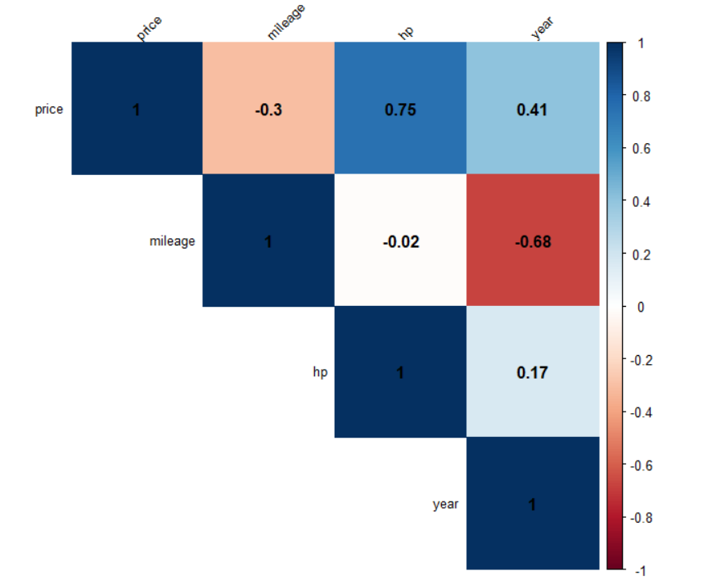

Hypothesis Testing

Question 1: Is there a significant difference in the average mileage (mpg) between petrol and diesel cars?

Hypotheses:

Null Hypothesis (H0): There is no significant difference in the average mileage between Gasoline and Diesel cars.

Alternative Hypothesis (Ha): There is a significant difference in the average mileage between Gasoline and Diesel cars.

Inferential Statistics: Distribution of mileage between the Gasoline and Diesel car are plotted using density graph. This shows that the distribution has a positive skew towards the right and from the density plot we can conclude that there is a separation between the mileage of gasoline cars vs the diesel cars.

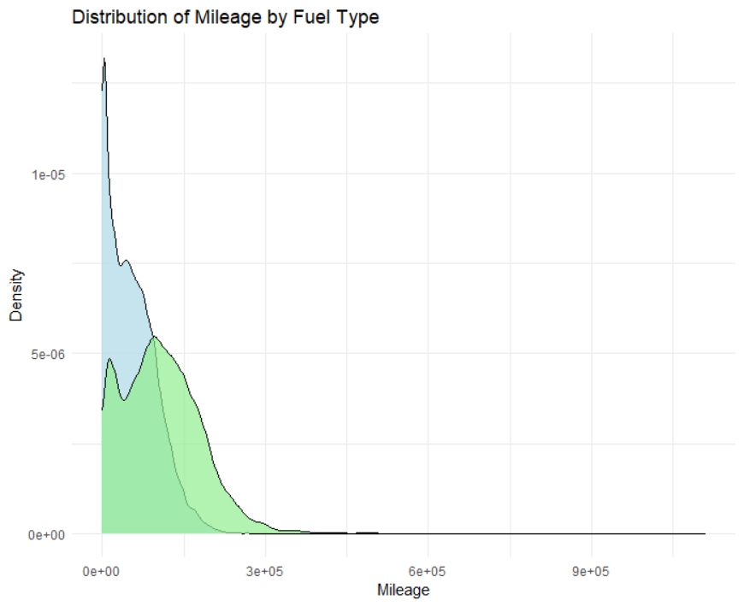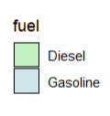

Hypothesis Testing: we infer a confidence interval of 95% from the data. Based on the outcome of the t.test, df stands in for N-1, the number is 21634. The P-value is much lower than 0.05, at 2.2e-16. Additionally, it can be inferred from the t value that t= -83.571, which is higher than the 95% confidence interval of +/- 1.96.

Thus, the Null Hypothesis that there is “no significant difference in the mileage of Gasoline and Diesel cars”, can be REJECTED based on the values of p and t.

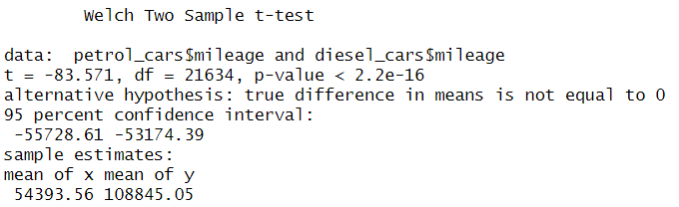

Regression Testing: The p-values associated with the coefficients indicate the significance of their effects on the mileage. The p-values are less than the chosen significance level, therefore, reject the null hypothesis and conclude that there is a significant difference in the average mileage between Gasoline and Diesel cars. A positive coefficient of 21261 suggests that the mileage is higher for Gasoline cars compared to Diesel cars.

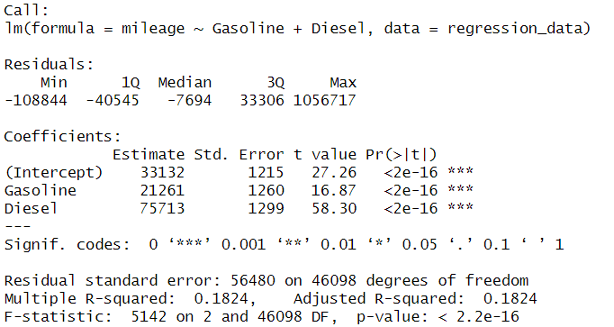

Question 2: Is there a significant difference in the average price of cars with manual and automatic transmissions?

Hypotheses:
Null Hypothesis (H0): There is no significant difference between the average price of manual and automatic cars.
Alternative Hypothesis (Ha): There is a significant difference between the average price of manual and automatic.

Inferential Statistics: The distribution of transmission types is skewed towards automatic transmission whereas manual cars have a normal distribution and density plot shows a higher peak and larger area under the curve for automatic transmission compared to manual transmission. This suggests that there are expensive cars with automatic transmission compared to the latter.

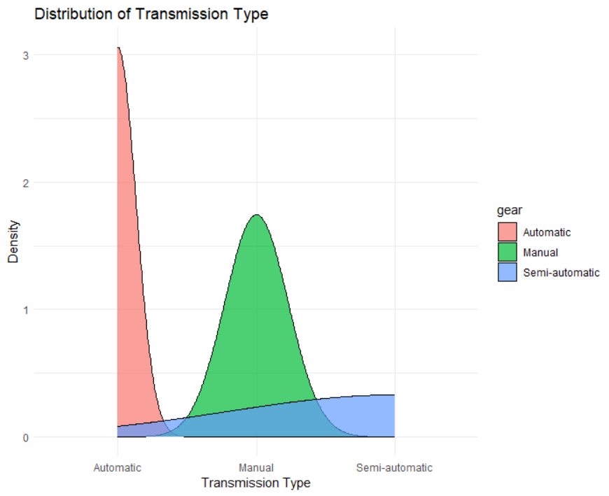

Hypothesis Testing: we infer a confidence interval of 95% from the data. Based on the outcome of the t.test, df stands in for N-1, the number is 16587. The P-value is much lower than 0.05, at 2.2e-16. Additionally, it can be inferred from the t value that t= -76.784, which is higher than the 95% confidence interval of +/- 1.96.

Thus, the Null Hypothesis that there is “no significant difference in the average price of automatic and manual cars”, can be REJECTED based on the values of p and t.

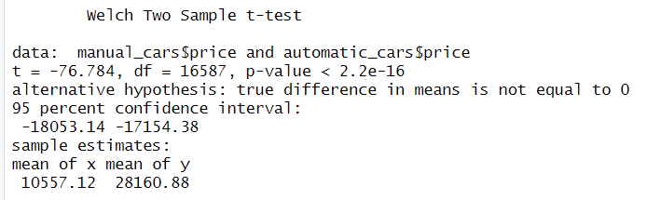

Regression Testing: The p-values associated with the coefficients indicate the significance of their effects on the transmission model. The p-values are less than the chosen significance level, therefore, reject the null hypothesis and conclude that there is a significant difference in the average price between automatic and manual cars. A negative coefficient of -17603 suggests that the price is lower for Manual cars compared to automatics cars.

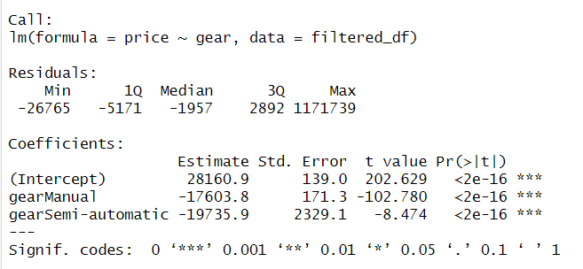

The regression line has a noticeable slope, it indicates that there is a significant difference in the average price between the two transmission types. In this case, it would provide evidence to reject the null hypothesis and support the alternative hypothesis that there is a significant difference in the average price of manual and automatic cars.

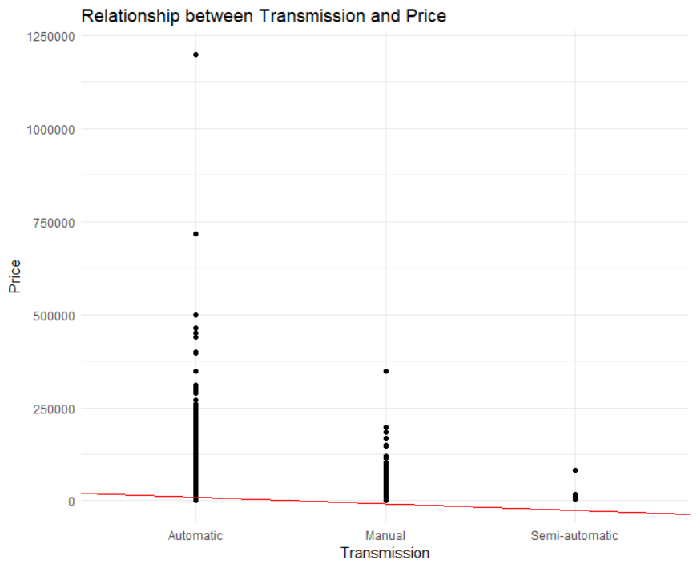

Question 3: Is there a significant difference between older high mileage Jettas and low mileage Civics.

Hypotheses:
Null Hypothesis (H0): There is no significant difference between the average price of high mileage Jettas and low mileage Civics.
Alternative Hypothesis (Ha): There is a significant difference between the average price of high mileage Jettas and low mileage Civics.

Inferential Statistics: The box plot suggests that there is no considerable overlap between the price ranges of older high mileage Jettas and low mileage Civics. This implies that, on average, there may be a significant difference in prices between the two groups.

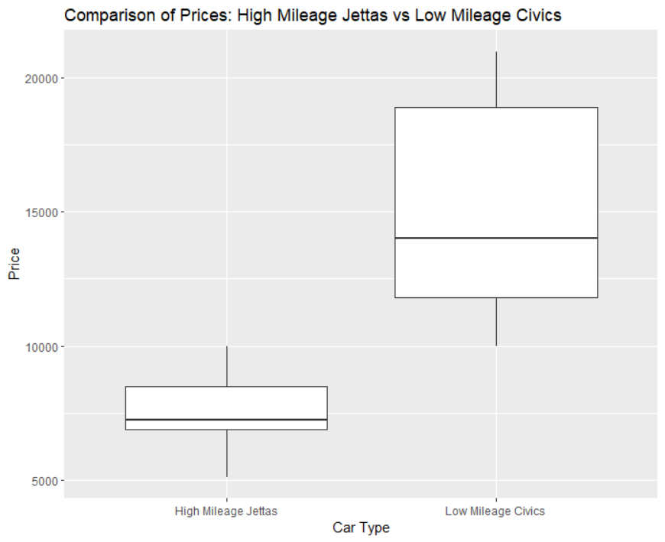

Hypothesis Testing: we infer a confidence interval of 95% from the data. Based on the outcome of the t.test, df stands in for N-1, the number is 26. The P-value is much lower than 0.05, at 1.97e-07. Additionally, it can be inferred from the t value that t= -6.9942, which is higher than the 95% confidence interval of +/- 1.96. The negative sign indicates that the average price of older high mileage Jettas is lower compared to low mileage Civics.

Thus, the Null Hypothesis that there is “no significant difference in the average price of older high mileage Jettas and low mileage Civics”, can be REJECTED based on the values of p and t.

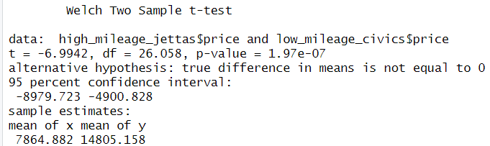

Regression Testing: The regression model suggests that there is a significant relationship between the mileage and price of the cars in the dataset. The negative slope of the regression line indicates that as the mileage increases, the price tends to decrease. The intercept of the regression line represents the estimated price when the mileage is zero. However, since it is unlikely to have a car with zero mileage, the intercept may not have a practical interpretation in this context. By visually inspecting the scatter plot and the regression line, you can observe the general trend that as the mileage increases, the price tends to decrease.

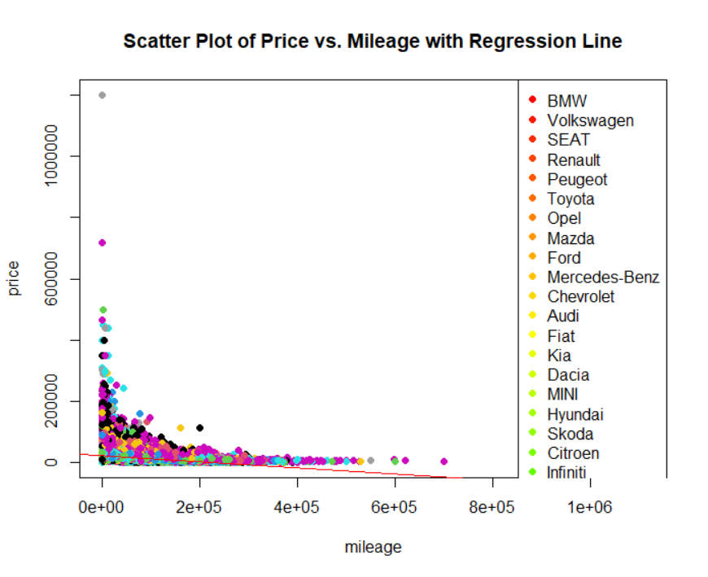

Summary

Key Takeaways:

The cars in the dataset are from various brands and come in a variety of models, production years, and price ranges.

Three key factors that significantly affect car sales are price, year and mileage

Price and other parameters like mileage and horsepower might be related, which can give important information about what influences automobile prices based on the corelation plot.

The cars in the dataset use a variety of fuels, with petrol being the most popular

The hypothesis testing clearly defines a relationship between the price of the vechile and the variables of mileage and type of transmission.

Bibilography

ggplot2 box plot : Quick start guide - R software and data visualization - Easy Guides - Wiki - STHDA. (n.d.). http://www.sthda.com/english/wiki/ggplot2-box-plot-quick-start-guide-r-software-and-data-visualization

Data Analysis and Visualisation in R for Ecologists: Data visualization with ggplot2. (2023, May 3). https://datacarpentry.org/R-ecology-lesson/04-visualization-ggplot2.html

Finnstats. (2021). How to Find Unique Values in R | R-bloggers. R-bloggers. https://www.r-bloggers.com/2021/12/how-to-find-unique-values-in-r/

https://www.kaggle.com/code/jcraggy/germany-cars-r/input
- R - Pie Charts. (n.d.). https://www.tutorialspoint.com/r/r_pie_charts.htm

